- Do not edit/delete any heading or section with red text.
- Type /paste you answers in relevant sections (below Final Answer (in all questions , Approach (wherever required ) and Charts & tables (wherever required)) of the solution
- Link to submission guidelines
- Please note that submission not following the guidelines will not be accepted

OBJECTIVE QUESTIONS

Question 1: What is the total no. of attributes present in the data?

Solution:

Final Answer (if any):
17
Approach (if any):
COUNTA(A1:Q1)
Charts & Tables (if any):
NA

Question 2: Which columns have inconsistent or missing values, and what is the count of such values?

Solution:

Final Answer (if any):
Unclasified → Unclassified
Mayor → Major
Unassiged →Unassigned
Fetcha → Date
Missing values - 0

Approach (if any):
Using filter check missing, unique column and check spelling mistake and use find and replace all with correct spellings.
Charts & Tables (if any):
NA

Question 3: What is the average daily ticket volume over time?

Solution:

Final Answer (if any):
53.36507937

Approach (if any):
=COUNTA('Cleaned Data'!A2:A97499)/ROWS(UNIQUE(INT('Cleaned Data'!B2:B97499)))
Charts & Tables (if any)
- Table / Chart Name:
Monthly wise count ID

- Description:
It present monthly wise count Id x axis have months and y contains counts of ticket id .

Question 4: What is the distribution of ticket categories (e.g., Login Access, System, Software)?

Solution:

Final Answer (if any):
Hardware | 9733
Login Access | 29193
Software | 19570
System | 39002
Grand Total | 97498

Approach (if any):
I have used pivot table row contains Request Category and values have count of ticket id.
Charts & Tables (if any):
- Table / Chart Name:
Distribution of ticket categories

- Description: It represents request category wise count of tickets

Question 5: How many tickets has each agent handled?

Solution:

Final Answer (if any):
In table actual answer.
Approach (if any):
Using pivot table rows have agent name and in value have Count of ticket Id.
Charts & Tables (if any):
- Table / Chart Name: Tickests handle by IT agents

- Description:
It shows name wise tickets how many tickets take agent.

Question 6: How can you extract the domain from the email addresses in the IT Agents sheet?

Solution:

Final Answer (if any):
Fp20analytics
Approach (if any):
formula -MID('IT Agents'!C2,FIND("@",'IT Agents'!C2)+1,FIND(".com",'IT Agents'!C2)-FIND("@",'IT Agents'!C2)-1)
Charts & Tables (if any):
- Table / Chart Name:
NA
- Description:
NA

Question 7: How can you find the full name of an agent given their Agent ID?

Solution:

Final Answer (if any):
All Agents name

Approach (if any):
=XLOOKUP(D2,'IT Agents'!$A$2:$A$51,'IT Agents'!$B$2:$B$51)
Charts & Tables (if any):
- Table / Chart Name:
NA
- Description:
NA

Question 8: What is the count of each issue type (e.g., IT Error, IT Request)?

Solution:

Final Answer (if any):
IT Error | 24278
IT Request | 73220
Grand Total | 97498

Approach (if any):
I have used pivot table Request category in rows and values have count of ticket id.
Charts & Tables (if any):
- Table / Chart Name:
Distribution of issues type

- Description:
Using Column chart and show the Distribution of issues type

Question 9: What is the average resolution time for tickets?

Solution:

Final Answer (if any):
4.553149808
Approach (if any):
Using pivot table monthly wise avg of resolution time.
Charts & Tables (if any):
- Table / Chart Name:
Monthly Average Resulation Time

- Description: in chart show monthly wise average of resolution time days .

Question 10: How has the volume of tickets changed over time?

Solution:

Final Answer (if any):
Years: Count Ticket:
2016 13051
2017 14915
2018 18954
2019 21490
2020 29088

Approach (if any):
Using pivot table rows contain months and values count of the ticket id. Evaluate monthly wise total volume of tickets.
Charts & Tables (if any):
- Table / Chart Name:
Monthly Trends Over Time

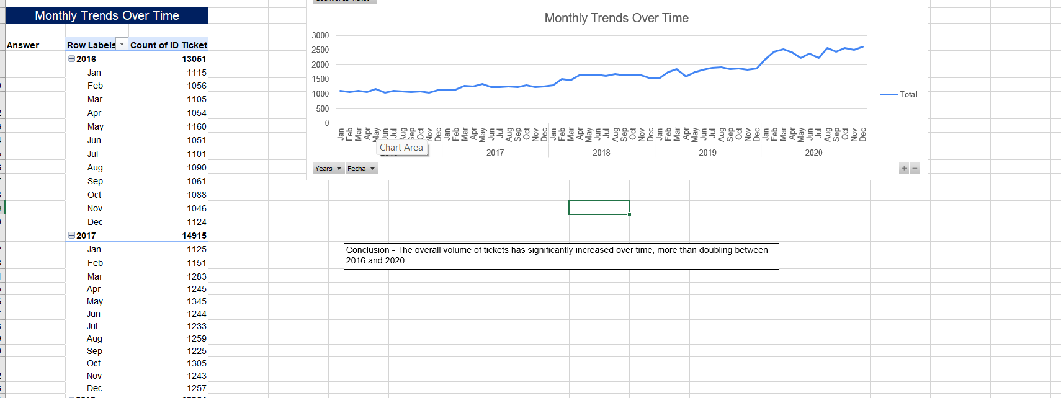

- Description:
It shows monthly wise trends over time

Question 11: What is the average age of the IT agents?

Solution:

Final Answer (if any):
41.08
Approach (if any):
=AVERAGE('IT Agents'!G2:G51)
Charts & Tables (if any):
NA

Question 12: Is there a correlation between the severity of issues and the resolution time?

Solution:

Final Answer (if any):
-0.040536349

Approach (if any):
=CORREL('Cleaned Data'!L2:L97499,'Cleaned Data'!I2:I97499)
Charts & Tables (if any):
NA

Question 13: How many categorical columns are there in the data? [Search about categorical and continuous data, and try to answer this question]

Solution:

Final Answer (if any):
- ID Ticket
- Employee ID
- Agent ID
- Request Category
- Issue Type
- Severity
- Priority
- Agent Name
- Age Bracket
- Resolution Time Bracket
Total categorical columns = 10
Approach (if any):
I classified each attribute based on its data type. Columns containing labels, groups, names, or identifiers were considered categorical. Based on this classification, the dataset contains 10 categorical columns.

Charts & Tables (if any):NA

SUBJECTIVE QUESTIONS

Question 1: If there is an investment, should it be used to hire more IT agents, improve training programs, or upgrade ticket management software?

Analysis: Perform a cost-benefit analysis using ticket resolution and satisfaction metrics.

Solution:

Approach:
I compared the number of tickets, average resolution time, and customer satisfaction. I also checked the workload of each IT agent and the type and severity of tickets. This helps decide where the investment will have the biggest impact.
Charts & Tables:
Table 1: Agents workload
- Description: Shows the number of tickets handled by each IT agent, along with their average resolution time and satisfaction rate.
Table 2: Request Categories
- Description: Shows ticket volume, resolution time, and satisfaction for Hardware, Login Access, and Software requests.
Table 3: Severity
- Description: Shows ticket volume, resolution time, and satisfaction for different ticket severity levels.
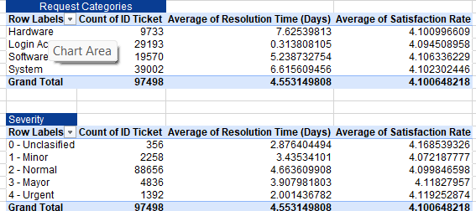
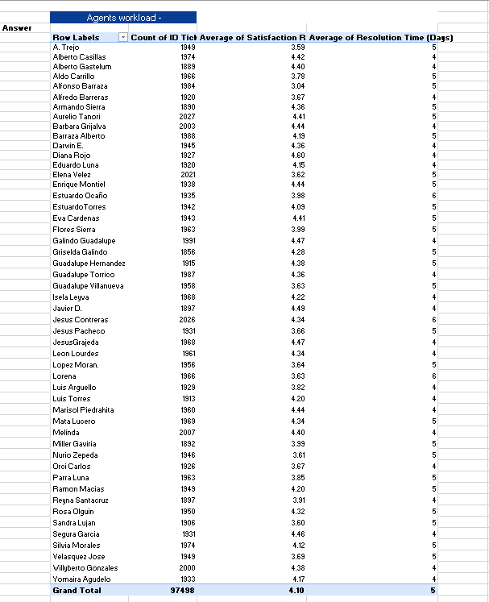

Insights:
- The IT department handles an immense operational burden, managing a grand total of 97,498 tickets.
- The workload is evenly distributed across the entire team, with individual agents locked into a heavy capacity of roughly 1,850 to 2,030 tickets each.
- Infrastructure issues are the primary driver of volume, with the System category alone generating the highest number of requests at 39,002 tickets.
- Complex technical workflows are severely delayed, as Hardware requests take an average of 8 days to close, closely followed by System tickets at 7 days.
- While emergency routing works well for Urgent tickets (2 days), the queue is heavily clogged by the "2 - Normal" tier, which holds an overwhelming 88,656 tickets and averages a slow 5-day resolution time.

Recommendations:
- Focus on training programs for Hardware and System issues, as they have the longest resolution times.
- Improve handling of Normal-severity tickets, which have the highest volume.
- Consider software upgrades to improve ticket routing and tracking.
- Consider hiring more agents only if workload analysis shows current staffing is insufficient.

Question 2: Which agents need additional training based on their performance metrics?

Analysis: Identify agents with the lowest satisfaction ratings and longest resolution times.

Solution:

Approach:
I compared each agent's average resolution time and average satisfaction rate with the overall team averages. Agents with higher-than-average resolution time and lower-than-average satisfaction were identified for further training review.
Charts & Tables:
Table/Chart Name: Average Resolution Time and Average Satisfaction Rate by Agent
Description:
The table and chart compare each agent's resolution time with their customer satisfaction score. This helps identify agents who may need extra training.

Insights:

  - The team averages are approximately 4.55 days for resolution time and 4.10/5 for satisfaction.
  - Agents with resolution time above 4.55 days and satisfaction below 4.10 should be reviewed first for additional training.
  - Lorena is a key example, with approximately 6 days average resolution time and 3.62/5 satisfaction, indicating both speed and satisfaction concerns.
  - Agents with low satisfaction but normal resolution time may need customer-service or communication training rather than technical training.
  - Agents with higher resolution time but acceptable satisfaction may need technical or workflow support.
  - Ticket workload should also be considered before judging performance, because agents handling different volumes or request types may have different resolution times.

Recommendations:
- Provide targeted training to agents who are above the 4.55-day resolution benchmark and below the 4.10/5 satisfaction benchmark.
- For agents with high resolution time, provide technical and workflow training.
- For agents with low satisfaction, provide customer-service and communication training.
- Review their previous tickets and request categories to identify the reason for slower resolution or lower satisfaction.

Question 3: Do certain categories of requests have longer resolution times?

Analysis: Analyze the resolution times by request category.

Solution:

Approach:
I compared the average resolution time for each request category. I also checked the number of tickets to understand which categories have the biggest workload.
Charts & Tables:
Table 1: Average Resolution Time by Request Category
Description:
This table shows the number of tickets and average resolution time for Hardware, Login Access, Software, and System requests.
Table 2: Average Resolution Time by Severity
Description:
This table shows how resolution time changes based on ticket severity.
Chart 1: Average Resolution Time by Request Category (days)
Description:
The bar chart compares the average time needed to resolve each request category.
Chart 2: Average Resolution Time by Severity
Description:
The chart compares resolution time for different severity levels.

Insights:
- Hardware requests have the longest average resolution time at about 7.63 days.
- System requests are also high at about 6.62 days.
- Software requests take about 5.24 days.
- Login Access requests are the fastest at about 0.31 days.
- Hardware and System requests take much longer than Login Access requests.
- Normal severity tickets have the highest resolution time among the severity levels, at about 4.66 days.
- Urgent tickets are resolved faster, at about 2.00 days.

Recommendations:

- Focus on Hardware and System requests first because they take the most time.
- Check whether these tickets need specialist staff, better processes, or additional resources.
- Provide extra training to agents who handle Hardware and System issues.
- Improve ticket routing so complex Hardware and System tickets reach the right team quickly.

Question 4: How effective are the current software tools in managing IT tickets?

Analysis: Evaluate performance metrics before and after the implementation of new tools.

Solution:

Approach:
I compared average resolution time and satisfaction rate by year to identify changes in IT support performance over time. I also created a Severity × Priority analysis to check whether ticket priorities are appropriately assigned based on severity. Request Category performance was used to identify areas with longer resolution times.
Charts & Tables:
Table : Request Category Performance

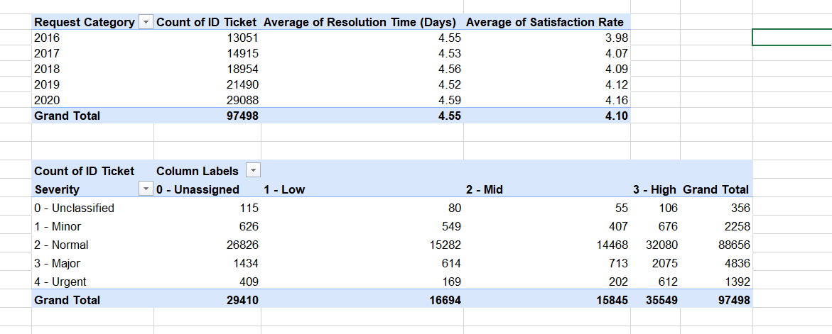
Description:
This table compares ticket volume, resolution time, and customer satisfaction for each request category.
Insights:
  - Ticket volume increased from 13,051 in 2016 to 29,088 in 2020, while average resolution time stayed stable at around 4.5 days.
  - Customer satisfaction improved from 3.98/5 in 2016 to 4.16/5 in 2020.
  - Normal severity has the largest workload, with 88,656 tickets.
  - Within Normal severity, 3 - High priority contains 32,080 tickets, followed by 0 - Unassigned with 26,826 tickets.
  - The Severity × Priority table helps identify tickets that may need a review of their priority assignment, particularly high-severity tickets that remain unassigned or low priority.

Recommendations:
- Improve automatic ticket routing and prioritization, especially for high-severity tickets.
- Review unassigned and low-priority tickets within higher-severity categories to reduce possible delays.
- Continue monitoring resolution time and satisfaction annually, because ticket volume is increasing while resolution time remains stable.
- Improve automation for Hardware and System requests, which have the longest resolution times.
- Use the Severity × Priority report regularly to identify and correct inappropriate priority assignments.

Question 5: How has the performance of the IT support team changed over time (e.g., monthly or quarterly)?

Analysis: Trend analysis using time series charts.

Solution:

Approach:
I used a PivotTable grouped by Year and Month to compare ticket volume, average resolution time, and average satisfaction rate over time. I also used a time-series chart to identify monthly and yearly trends. Finally, I performed a What-If analysis to estimate the impact of reducing the current average resolution time by 5% and 10%.
Charts & Tables:
Table 1: IT Support Performance by Month
Description:
This table shows the number of tickets, average resolution time, and average satisfaction rate for each month.
Chart 1: IT Support Performance Over Time
Description:
The line chart shows how the team's average resolution time changed from January to December.
A | B | C
Scenario | Average Resolution Time | Improvement
Current | 4.55 | —
5% improvement | 4.3225 | 0.2275
10% improvement | 4.095 | 0.455

Insights:
- Ticket volume increased over the years, with the highest monthly volumes occurring in the later years.
- Average resolution time remained relatively stable at around 4.55 days overall.
- Average satisfaction rate improved from approximately 3.98 in 2016 to above 4.0 in later years.
- Monthly resolution time and satisfaction rate show some fluctuations throughout the period.
- In the What-If analysis, a 5% improvement would reduce average resolution time from 4.55 to 4.32 days, saving approximately 0.23 days.
- A 10% improvement would reduce it to approximately 4.10 days, saving about 0.46 days.

Recommendations:
- Continue monitoring ticket volume, resolution time, and satisfaction monthly.
- Target a 10% reduction in average resolution time, from 4.55 to approximately 4.10 days.
- Investigate months with unusually high resolution times to identify workflow or workload issues.
- Review high-volume periods and ensure workload is distributed effectively among agents.

Track the results after improvements to check whether the 4.10-day target is achieved

Question 6: If we invest more on tech (Hardware, software, etc), do you think it will improve the ticket resolution times and employee satisfaction?

Analysis: Use historical data to project potential improvements.

Solution:

Approach:
Firstly find the categories that take the longest time to solve to see where technology is failing or missing. Look at the satisfaction scores across all categories to see if users are already happy with how things work. Connect categories like Hardware (8 days) and System (7 days) to a lack of better technical tools or automation software.

Charts & Tables:
Chart Name:
Resolution Time and Satisfaction by Request Category
Description:
This chart compares the average resolution time and average satisfaction for each request category. It shows that Hardware and System requests take longer to resolve, while satisfaction remains around 4.1.

Insights:
- Technology will help lower resolution times because complex areas like Hardware take 8 days and System takes 7 days to fix.
- Employee satisfaction is already very high and steady at 4.10 out of 5 across all categories.
- Investing in tech will not change satisfaction much since it is already good, but it will massively speed up slow workflows.
- Simple automated routing is already working well because Login Access takes 0 days to fix.
- New tech upgrades should target Hardware and System tools specifically to cut down the long 7-to-8 days delays.

Recommendations:
- Invest in better hardware and system tools to reduce delays.
- Improve ticket management and automation for Hardware and System requests.
- Provide agents with better tools to diagnose and solve technical problems faster.
- Combine technology investment with agent training and better ticket routing.

Question 7: What are the key performance metrics for IT agents, and how can they be improved, do we need to fire any agents?

Analysis: Define and analyze metrics such as average handling time, satisfaction scores, and number of tickets resolved.

Solution:

Approach:
I compared each agent using three key performance metrics: average resolution time, average satisfaction rate, and number of tickets handled. I also reviewed the request categories handled by each agent to understand possible reasons for differences in performance. Agents with high resolution time, low satisfaction, or unusually high workload can be reviewed for further support and training.

Charts & Tables:
Table/Chart Name: Agent Performance Metrics
Description:
The table/chart compares each IT agent's resolution time, satisfaction score, and ticket workload. It helps identify agents who may need improvement.

Insights:
  - The team averages are approximately 4.55 days resolution time and 4.10 satisfaction rate.
  - Trejo has a higher-than-average resolution time of 5 days and lower satisfaction of 3.59, so this agent should be reviewed.
  - Alfonso Barraza has 5 days average resolution time and the lowest satisfaction among the displayed agents at 3.04, indicating a need for targeted coaching.
  - Elena Velez also shows higher resolution time (5 days) and lower satisfaction (3.62) than the team averages.
  - Estuardo Ocaño has the highest resolution time among the displayed agents at 6 days, while satisfaction is 3.98, below the team average.
Recommendations:
- Do not fire any agents based only on this data.
- Give weaker-performing agents specific training and coaching.
- Review their previous tickets to find the real reason for poor performance.
- Improve ticket routing so complex tickets go to the right agents.
- Set clear targets for resolution time and satisfaction.
- Check their performance again after 3–6 months.

Question 8: How do employee demographics (e.g., department, seniority) impact satisfaction and ticket outcomes?

Analysis: Segment analysis using filters and pivot tables.

Solution:

Approach:
I used a pivot table to compare agent age groups based on the number of tickets, average resolution time, and average satisfaction. This helps see whether age groups have different performance results.
However, the available data only shows agent age. It does not contain department or seniority/job level, so we cannot measure their impact.
Charts & Tables:
Table Name: Agent Age Bracket Performance
Description:
The table compares ticket volume, average resolution time, and average satisfaction for different agent age groups.
Chart Name: Avg Resolution Time & Satisfaction by Agent Age Bracket
Description:
The chart compares average resolution time and satisfaction across different agent age groups.
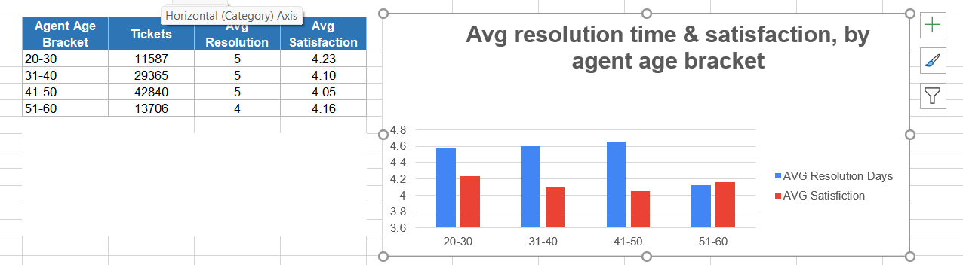

Insights:
- The 41–50 age group handles the highest number of tickets (42,840).
- The 20–30 age group has the highest satisfaction score (4.23).
- The 41–50 age group has the lowest satisfaction score (4.05).
- The 51–60 age group has the lowest average resolution time at 4 days.
- The other age groups have an average resolution time of about 5 days.
Recommendations:
- Do not make staffing or firing decisions based on age alone.
- Check why the 41–50 group has lower satisfaction and whether workload is a factor.
- Share successful practices from higher-satisfaction groups.
- Use training and workload balancing to improve performance.

Question 9: Identify the trends for IT support operations based on ticket volumes and satisfaction, and mention the peak and stable times?

Analysis: Use pivot tables and charts to identify peak and off-peak hours.

Solution:

Approach:
I find the months with the highest and lowest number of tickets using the table and the blue line on the chart. Look at the red line to see if customer satisfaction changes when the team gets busier.
Spot the exact months where the workload spikes up or stays the same.
Charts & Tables:
Table Name: Monthly Ticket Volume and Satisfaction
Description:
The table shows the number of IT tickets and average customer satisfaction for each month from January to December.
Chart Name: IT Support Trends – Ticket Volume and Satisfaction
Description:
The chart shows how ticket volume and satisfaction change throughout the year. It helps identify busy and stable periods.
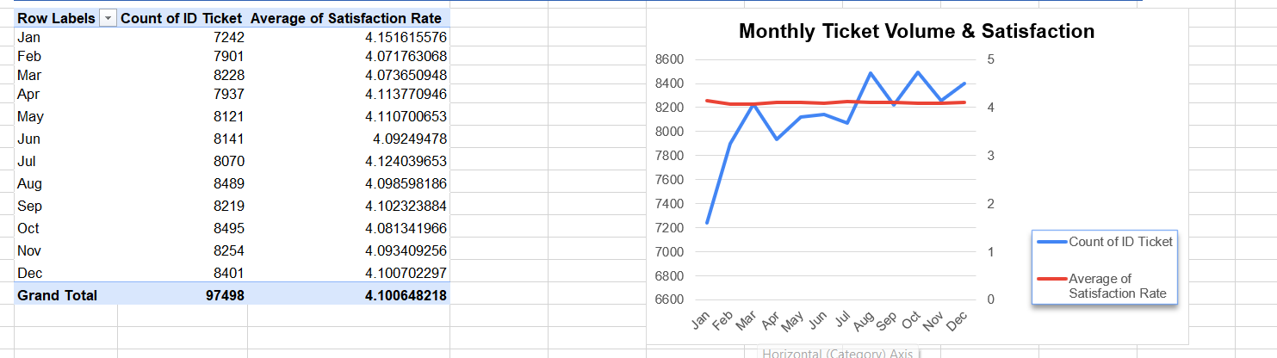

Insights:
  - Ticket volume changes throughout the year, with January having the lowest volume at 7,242 tickets.
- The busiest peak times happen in August with 8,489 tickets and October with 8,495 tickets.
- The most stable times are in the spring from March to July, where volume stays steady around 8,000 to 8,200 tickets.
- Customer satisfaction stays completely steady and flat all year, averaging a 4.10 rating out of 5.
- The team handles busy periods very well because customer satisfaction does not drop even when the workload spikes.
Recommendations:
- Keep extra IT support available during August, October, and December, when ticket volume is high.
- Plan staff schedules according to expected ticket volume.
- Maintain the current support process because satisfaction is generally good.
- Monitor October closely because it has the highest workload.

Question 10: What metrics should be included in the final dashboard to provide a comprehensive view of call center performance and guide investment decisions?

Solution:

Approach:
I selected the most important metrics from the available IT support data. The dashboard should show ticket workload, resolution speed, customer satisfaction, request categories, severity, and agent performance. These metrics help management decide where investment is needed.
Charts & Tables:
Table 1: Overall Support Performance
 | KPI |  | Value
 | Total Tickets |  | 97,498
 | Average Resolution Time |  | 4.55 days
 | Average Satisfaction Rate |  | 4.10 / 5
Average Tickets per Agent |  | 1,949.96
Description:
Shows the main KPIs for the IT support team.

Insights:
- The team handles a large number of tickets (97,498).
- Average resolution time is 4.55 days, so reducing resolution time should be a priority.
- Satisfaction is good at around 4.10/5.
- Hardware and System tickets have the longest resolution times.
- Monthly ticket volume changes, with October having the highest volume (8,495).
Recommendations:
- Hire more IT agents to reduce the heavy workload of 97,498 total tickets.
- Give extra training for Hardware and System issues to fix long 7-to-8 day delays.
- Add more staff in October to handle the biggest yearly ticket spikes.
- Keep using the current routing system because urgent tickets are already fast-tracked.
- Use the 4.55-day resolution baseline to measure if new tech investments help speed up work.

